**Introduction**  
  
Lets look at the basics of candlesticks.  In this section we'll look at the different shapes of candlesticks and what they mean in terms of price action, the battle between bulls and bears and trader psychology.  We'll also look at their trading limitations and what they can't tell us.

When you're faced with a candle, how do you read it and what is meant by "reading"?  Well, in actual fact we are really asking "Who is in control and how do we read trader's sentiment"? This is done by looking at the components of the individual candlestick - the open and close of the body and the high and low of the shadow (wick and tail). Candlesticks come in many shapes and sizes and each shape tells the trader something different about sentiment. Whether we have long or stumpy bodies, long or short shadows, or a combination of them all, each candle tells it's own story.

In our diagram below we can see that the L.H.S (Left hand side) candlestick is black (It can also be red) and represents the price action in a particular period (1 min, 5 mins, 1 hour, 1 day, 1 week etc...See the [Basics of Charting](https://sites.google.com/site/tradingstrategiesschool/module-1-an-intro-to-technical-analysis/charting)). The opening price of the period is above the closing price and the period's price fluctuates between the high and low which are highlighted by the top and the bottom of the shadow.  The R.H.S candle is white (or Green) with the opening price being at the bottom of the body and the closing price situated at the top of the body.

[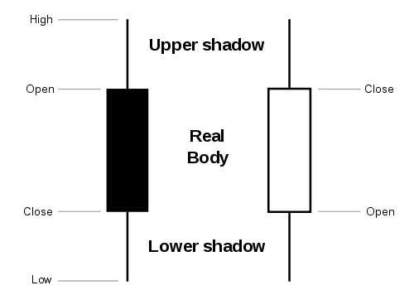](https://sites.google.com/site/tradingstrategiesschool/module-5-candlestick-chart-patterns-price-action/candlesticks---the-basics/Candlestick%20simple.png?attredirects=0)

Now, you may think that black (red) represents bearish sentiment and white (green) represents bullish sentiment?  In long bodied candle's, like the ones above this is usually correct and the longer the body in relation to the whole candle the better.  So, here the black candle represents the bears (or sellers) in control, where the bears were willing to sell at these price's. The white candle represents the bulls (or buyers) in control, where the bulls were willing to buy at these prices, thus driving the price higher. **But this isn't always the case** - sometimes colour doesn't play a part in sentiment and we'll discover why below.

**Long Bodied Candlesticks**

Let's continue with long bodied candles for now. In the below **daily** chart of RIMM we can see examples of many candlestick formations as well as long body candles.  The **green hollow long candlesticks represents a day where buyers were in control for long periods of the day** and the **red filled long candle represents sellers in control for long period of the day** and actually won the day.  Just to through a a spanner in the works, **you'll notice filled green candlesticks.  They are filled candles, so sellers won this period**.  Explanation - They're green because they closed above the last periods close and they're filled because they have closed below their open. This is possible because pre-market trading has lifted the price from the last periods close to this periods open.

In general whatever the colour, **hollow means buyers are in control and filled means sellers are in control** during that period.  **The extended length of the candles represents greater buying and selling pressure** within that specific period.  **Marubozu (Means "Bald" in Japanese) Candles don’t have wicks or legs** (wicks and legs are sometimes called shadows) and are even more potent long candles since buyers and sellers have controlled the whole session.

**Long candlesticks are generally bullish or bearish, but as with all technical analysis it really depends on where they are situated on the chart**. A long hollow candle on a long advance can mean new bullish pressure and lead to excessive bullishness, while a long filled candle can lead to panic, or over selling during a long decline. Conversely, after extended declines a long hollow candle can indicate support has been reached or a possible reversal point. The same goes for a long filled candle on a long advance.

[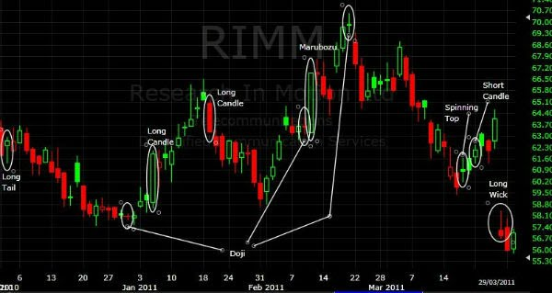](https://sites.google.com/site/tradingstrategiesschool/module-5-candlestick-chart-patterns-price-action/candlesticks---the-basics/candlestick%20basics.JPG?attredirects=0)

RIMM - Examples of Candlestick Formations

**Long Shadow Candlesticks**  
  
**One Long Shadow**

Long wicks and tails represent **price action that moved extensively during the period, but the closing price was fairly near to the open**. A long tail (shadow) and short wick indicates sellers made large gains, but in the end buyer’s regained control to push prices back up. These candlesticks are called **“The Hammer” or “Hanging Man”** and mostly (but not always) represent bullish sentiment, as there has been a rejection of lower prices. Similarly if there is a long wick, short tail (shadows) and the body is fairly small towards the bottom, buyers may have initially been in control, but sellers closed the day stronger. These candles are called **“Inverted Hammer” and “shooting star”** and mostly represent a bearish outlook as as sellers eventually sold at these higher prices. I’ve highlighted a long wick and tail in our RIMM chart. These long wick or tail candlesticks may represents a reversal of sorts, which we go on to talk about in the next section - [Candlesticks and the Reversal.](https://sites.google.com/site/tradingstrategiesschool/module-5-candlestick-chart-patterns-price-action/candlestick-reversal-patterns)

**Two Long Shadows**

Candlesticks with long wicks and tails, with a relatively short body are called **spinning tops** (e.g. drawn on RIMM chart). **These spinning tops represent indecision**. Both bears and bulls have been active during this period, but in the end the close is fairly close to the open. These spinning tops (hollow or filled) are good indicators after a long candlestick or after a long bull or bear run. **They represent potential weakness and a potential change in trend**. We can see the reversal implications in the next section "[Candlesticks and the Reversal](https://sites.google.com/site/tradingstrategiesschool/module-5-candlestick-chart-patterns-price-action/candlestick-reversal-patterns)". The Doji (with tiny bodies) are a special two-long shadow candle and will be a **more robust indicator** than a general two long shadow candle that has a larger body than the Doji.  We'll discuss Doji below.

**Short Candlestick**  
Short candles represent a period where neither buyers nor sellers have really won and there is little price action. **They have small price ranges from high to low**. They may be **seen as a period of consolidation depending on where they sit** within other period’s price action. They **may also be significant if they show up at the top or bottom of a trend as they may represent a reversal** and the battle between supply and demand changes. Further confirmation through Technical analysis will be necessary. We can see the reversal implications in the next section on [The Reversal](https://sites.google.com/site/tradingstrategiesschool/module-5-candlestick-chart-patterns-price-action/candlestick-reversal-patterns), as there are similarities. The Doji however, will be a more robust indicator than a short candlestick

**Why Do Many Candlestick Patterns Have Japanese Names?**

**Many distinctive candlestick patterns have Japanese names because of 17th century rice traders.  These rice traders used a form of T.A to try to understand the price action of their commodity and the names have stuck to this day with chartists. So you can see that price action in a trading environment has been around for hundreds of years.**

**Doji Candlesticks**   
  
Doji (The Japanese for "Unskilled") Candlesticks are a special case. They form when **the markets open and close are virtually equal** during that period. **Ideally the open and close should be equal and greater emphasis will be put on these doji**, but it is not necessary as it’s more important to capture the spirit of the candlestick. The length of the wick and tail can vary as seen on the RIMM chart above. **Doji are unbiased in price action** **where neither buyers nor sellers win the day** and open and close prices are equal or almost equal. **There significance is based on preceding price action and the future confirmation.** We'll explore their reversal and support & resistance significance in the next few sections in this module.  
  
Obviously a penny stock will have a better chance of an equal open and close than a £100 stock and a less volatile stock will also have a better chance of this “ideal” doji. Traders will need to scan the securities history for price and volatility to determine what a good doji may be. I.e. **a doji surrounded by small candlesticks may not be as significant as one surrounded by large sticks**. Tails and wicks can vary as I’ve highlighted in the next graphic.

[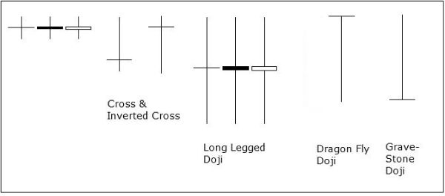](https://sites.google.com/site/tradingstrategiesschool/module-5-candlestick-chart-patterns-price-action/candlesticks---the-basics/doji.jpg?attredirects=0)

Types of Doji

**Types of Doji**

Lets go through the above graphic, showing different types of Doji.  Long Legged Doji reflect price action volatility during that period, but in the end there's uncertainty between bulls and bears as price settles near, or on the opening and closing price.

Cross and Inverted cross Doji have similar price action to Long wicks and tails candles. The cross doji implies that sellers had the bulk of the trading, but buyers came back to neutralise the price and the opposite is associated with the inverted cross.   
  
Dragonfly Doji indicate sellers had the early session, but buyers came back to neutralise the selling action and in the end the open, close and high are identical.   
  
The Gravestone indicates that buyers had the initial trade, but sellers won the period - the open, close and low were identical. Sellers came back to push prices to the low of the session.

**The Limitations of Candlesticks**  
Candlestick cannot tell us all the sequence of events during the session. **We know the open, close, high and low of the session, but we can’t really tell if the high or low came first**. The assumption is that prices declined for most of the session if we’re confronted with a long filled candlestick (red, black etc…). **In reality the price could have fluctuated** several times prior to reaching the closing price. Instead of facing strong sustained selling pressure, the session could have been more volatile. Just something we need to keep in the back of our minds and why **we need further confirmations when we go on to talk about the reversal implications** of some candlestick shapes.

Technical analysis is not an exact science and although these indicators, candlesticks and patterns can increase the probability of making the correct trade, many will go against you and large losses can be incurred. Your own trading strategy needs to be formed and hopefully you'll be on your way to achieving this on completion of this course.